BFS TRAVERSAL

NAME: J.L.PUGAZH MUKILAN

REG NO: 22BCE9292 SLOT :L7+L8

BFS CODE:

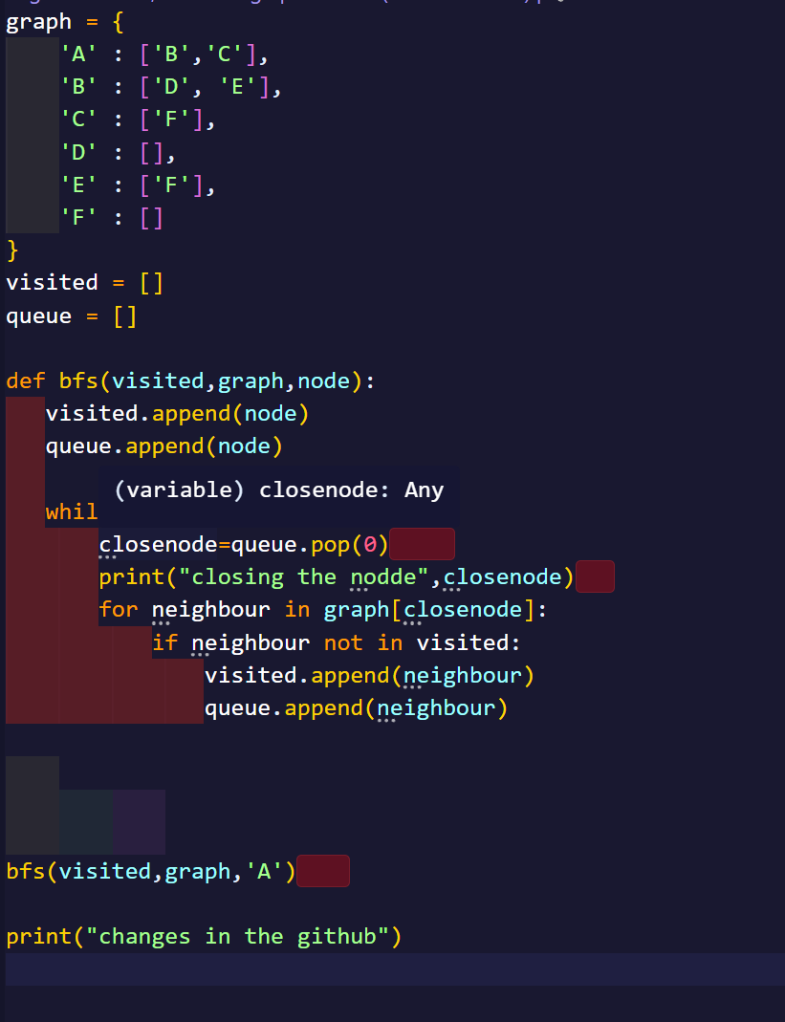

OUTPUT:

